**DAILY ONLINE ACTIVITIES SUMMARY**

|  |  |  |  |  |  |  |  |  |
| --- | --- | --- | --- | --- | --- | --- | --- | --- |
| **Date:** | **04-6-2020** | | | | | **Name:** | **Likhitha.M** | |
| **Sem & Sec** | **6th sem ‘A’** | | | | | **USN:** | **4al17cs046** | |
| **Online Test Summary** | | | | | | | | |
| **Subject** | | **Operating Systems** | | | | | | |
| **Max. Marks** | | **30** | | **Score** | | | **17** | |
| **Certification Course Summary** | | | | | | | | |
| **Course** | **Cloud Foundations** | | | | | | | |
| **Certificate Provider** | | | **Great learning** | | **Duration** | | | **3 days** |
| **Coding Challenges** | | | | | | | | |
| **Problem Statement:**  1.Python program to combine the strings  Description:  Take two strings, return a string of the form short+long+short, with the shorter string on the outsides and the longer string on the inside. The strings will not be the same length, but they may be empty (length 0).  Eg: Str1= 'Hello' Str2= 'Hi' Combined_str('Hello', 'Hi') ='HiHelloHi'  2. Write a Java program to implement Queue Using Array And Class | | | | | | | | |
| **Status: completed** | | | | | | | | |
| **Uploaded the report in Github** | | | | | **yes** | | | |
| **If yes Repository name** | | | | | **https://github.com/likhithaMantaral/Daily-status** | | | |
| **Uploaded the report in slack** | | | | | **yes** | | | |

Online test Details:

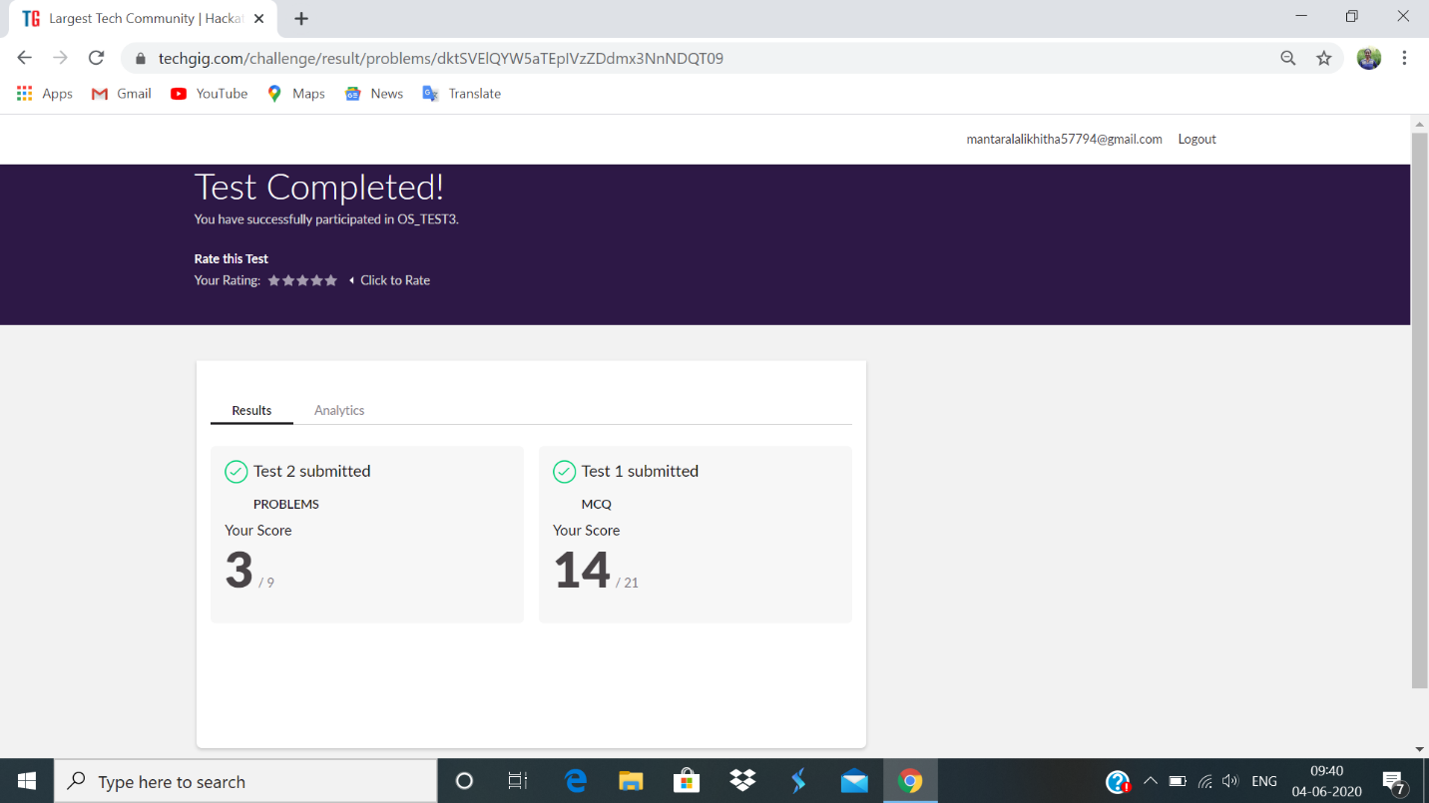

Certification Course Details:

**Infra. Automation, Abstraction, provisioning, Allied tech**

Infrastructure Automation

Cloud provider operations as well as inhouse IT management is not getting easier.

Solution is- chef.io, puppet.com, Ansible.com.

Central code repositories- SVN, GIT.

Auto build process- create “machine images” or “container images”.

Triggered at time of checkin, scheduled build.

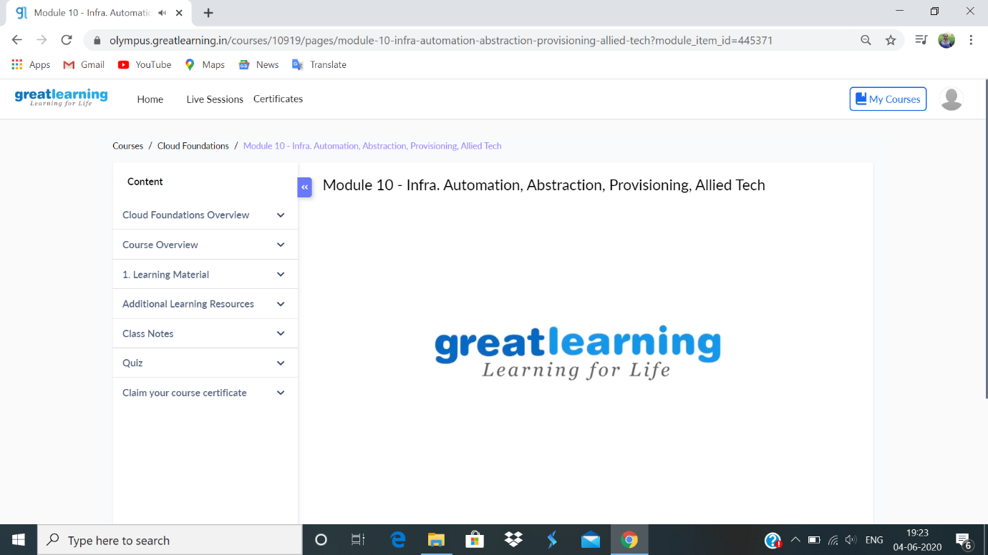

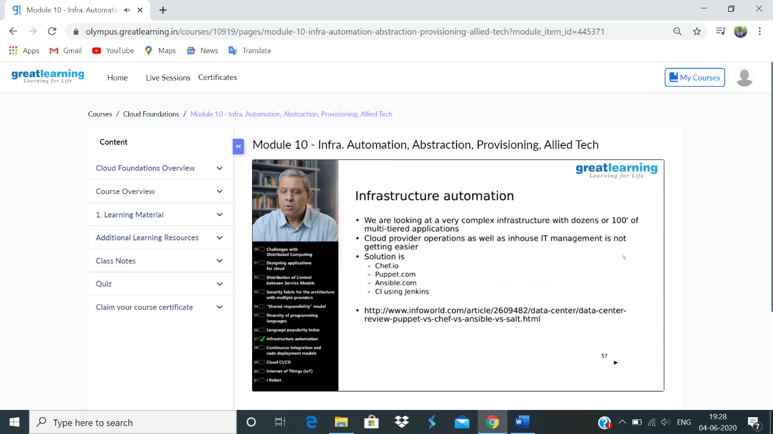

**Coding challenge:**

**1.**

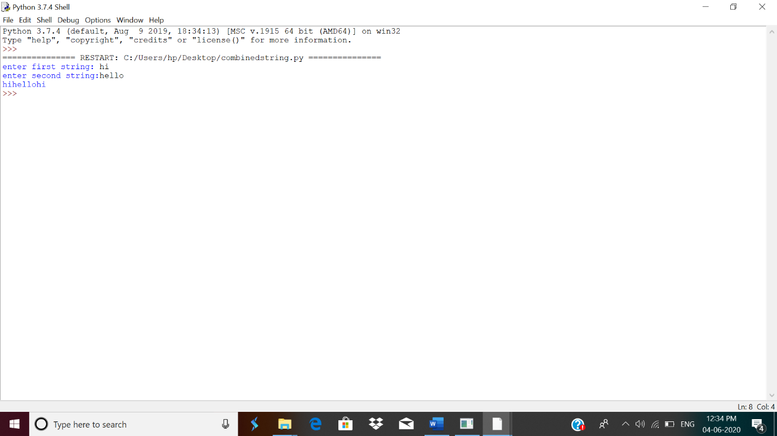

2.

